**INSTITUTE OF ENGINEERING**

ADVANCED COLLEGE OF ENGINEERING AND MANAGEMENT

Kupondole, Lalitpur

**(AFFILIATED TO TRIBHUVAN UNIVERSITY)**



Lab no:2

Subject: Computer Network

**Submitted By: Submitted To:**

Department of Computer

and

Electronics Engineering

Name: Sameep Dhakal

Roll no: ACE074BCT063

Date: 09/07/2021

**Title: Dynamic Routing**

**Objective:**

To learn about the basic concept of dynamic routing

**Introduction:**

Dynamic Routing:

Dynamic routing, also called adaptive routing, is a process where a router can forward data via a different route or given destination based on the current conditions of the communication circuits within a system. The term is most commonly associated with data networking to describe the capability of a network to 'route around' damage, such as loss of a node or a connection between nodes, so long as other path choices are available. Dynamic routing allows as many routes as possible to remain valid in response to the change. There are several protocols that can be used for dynamic routing. Routing Information Protocol(RIP) is a distance-vector routing protocols that prevents routing loops by implementing a limit on the number of hops allowed in a path from source to destination. Open Shortest Path First (OSPF) uses a link state routing (LSR) algorithm and falls into the group of interior gateway protocols (IGPs). Intermediate System to Intermediate System (IS-IS) determines the best route for data through a packet-switched network. Interior Gateway Routing Protocol (IGRP) and its advanced form Enhanced Interior Gateway Routing Protocol (EIGRP) are used by routers to exchange routing data within an autonomous system.

RIP:

Routing Information Protocol(RIP) is a dynamic routing protocol which uses hop count as a routing metric to find the best path between the source and the destination network. It is a distance vector routing protocol which has AD value 120 and works on the application layer of OSI model. RIP uses port number 520.

Eigrp:

Enhanced Interior Gateway Routing Protocol (EIGRP) is a dynamic routing Protocol which is used to find the best path between any two layer 3 device to deliver the packet. EIGRP works on network layer Protocol of osi model and uses the protocol number 88.It uses metric to find out best path between two layer 3 device (router or

layer 3 switch) operating EIGRP. Enhanced Interior Gateway Routing Protocol (EIGRP) is a Cisco-proprietary hybrid routing protocol that contains features of distance-vector and link-state routing protocols. It is a network layer protocol which

works on the protocol number 88.

**Design:**

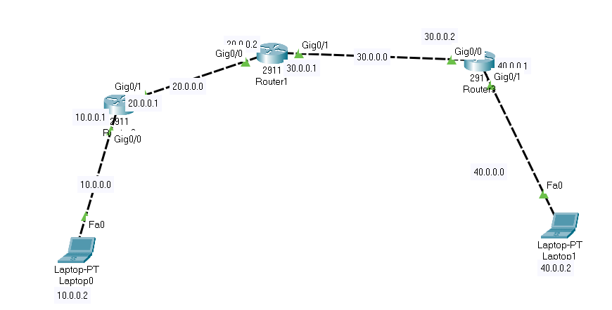

Two different laptops are connected using three different routers. The 2911 routers are used for the connection.

**Procedure:**

For RIP network:

1. First the required tools were selected.
2. The required ports of the routers were turned on.
3. Then the IP and subnet mask for each Laptop and router ports was set
   1. For laptops this was gone by going to the desktop and ip configurations

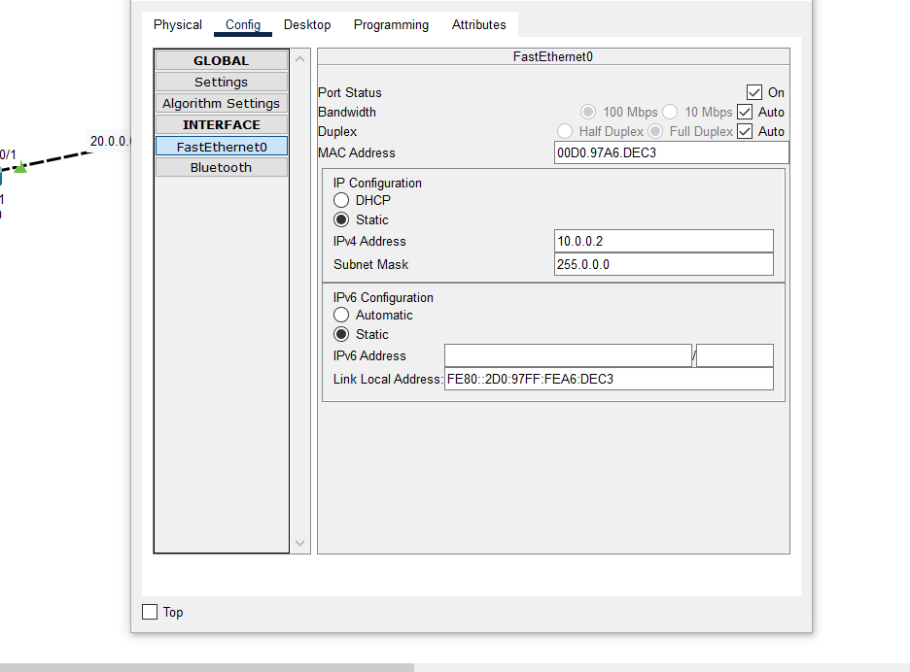

* 1. For routers this was done by going to the configuration and selecting the required port

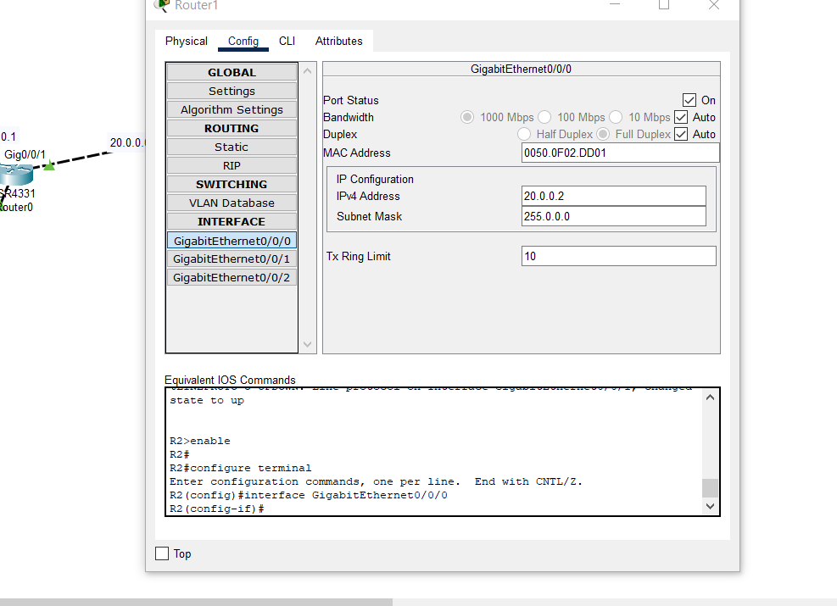

1. Required connections were made between the routers and laptops
2. The RIP network was added in the required routers through the routing section of the config tab

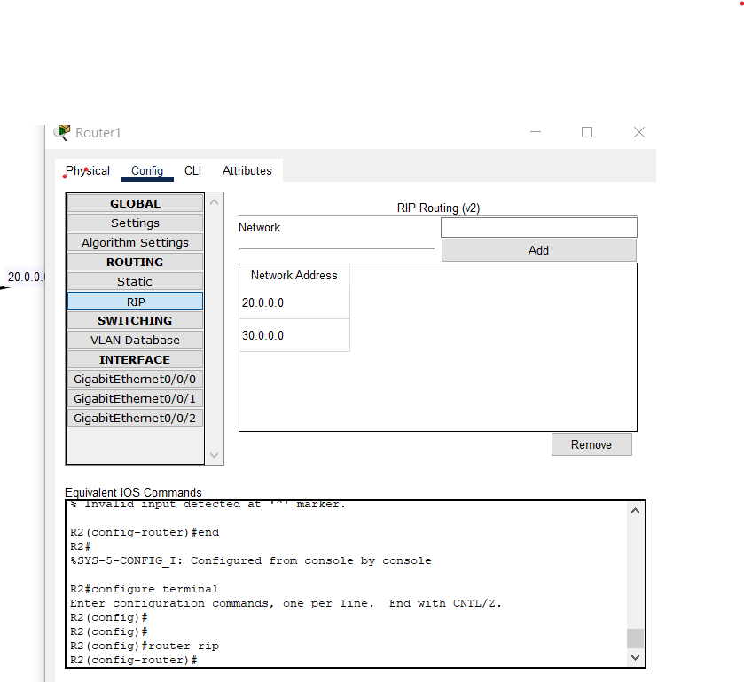

1. Then the routing information was given to each router through the routing option in the config tab.

For Eigrp:

For RIP network:

1. First the required tools were selected.
2. The required ports of the routers were turned on.
3. Then the IP and subnet mask for each Laptop and router ports was set
   1. For laptops this was gone by going to the desktop and ip configurations
   2. For routers this was done by going to the configuration and selecting the required port
4. Required connections were made between the routers and laptops
5. Then the routing information was given to each router through the routing option in the config tab.

Codes:

**RIP**

**Router 1**

Router>enable

Router#config terminal

Router(config)#hostname R1

R1(config)#interface g0/0

R1(config-if)#ip address 10.0.0.1 255.0.0.0

R1(config-if)#no shutdown

R1(config-if)#exit

R1(config)# interface g0/1

R1(config-if)#ip address 20.0.0.1 255.0.0.0

R1(config-if)#no shutdown

R1(config-if)#exit

R1(config)#router rip

R1(config-router)#version 2

R1(config-router)#network 10.0.0.0

R1(config-router)#network 20.0.0.0

R1(config-router)#exit

R1(config)#

**Router2**

Router>enable

Router#config terminal

Router(config)#hostname R2

R2(config)#i interface g 0/0

R2(config-if)#ip address 20.0.0.2 255.0.0.0

R2(config-if)#no shut

R2(config-if)#exit

R2(config)# interface g0/1

R2(config-if)#ip address 30.0.0.1 255.0.0.0

R2(config-if)#no shut

R2(config-if)#exit

R2(config)#router rip

R2(config-router)#version 2

R2(config-router)#network 20.0.0.0

R2(config-router)#network 30.0.0.0

R2(config-router)#exit

R2(config)#

**Router3**

Router>enable

Router#config terminal

Router(config)#hostname R3

R3 (config)#i interface g 0/0

R3(config-if)#ip address 30.0.0.2 255.0.0.0

R3(config-if)#no shut

R3(config-if)#exit

R3(config)# interface g0/1

R3(config-if)#ip address 40.0.0.1 255.0.0.0

R3(config-if)#no shut

R3(config-if)#exit

R3(config)#router rip

R3(config-router)#version 2

R3(config-router)#network 30.0.0.0

R3(config-router)#network 40.0.0.0

R3(config-router)#exit

R3(config)#

**EIGRP:**

**Command for Router 1**

Router>en

Router#conf t

Router(config)#host R1

R1(config)#int se0/0/0

R1(config-if)#ip addr 10.0.0.1 255.0.0.0

R1(config-if)#no shut

R1(config-if)#int se0/1/0

R1(config-if)#ip addr 20.0.0.1 255.0.0.0

R1(config-if)#clock rate 64000

R1(config-if)#no shut

R1(config-if)#exit

R1(config)#router eigrp 1

R1(config-router)#network 10.0.0.0

R1(config-router)#network 20.0.0.0

R1(config-router)#exit

wr

Building configuration...

[OK]

R1#

**Command for Router 2**

Router>en

Router#conf t

Router(config)#Host R2

R2(config)#int se0/0

R2(config-if)#ip addr 20.0.0.2 255.0.0.0

R2(config-if)#no shut

R2(config-if)#exit

R2(config)#int se2/0

R2(config-if)#ip addr 30.0.0.1 255.0.0.0

R2(config-if)#clock rate 64000

R2(config-if)#no shut

R2(config-if)#exit

R2(config)#router eigrp 1

R2(config-router)#network 20.0.0.0

R2(config-router)#

R2(config-router)#network 30.0.0.0

R2(config-router)#exit

R2#wr

Building configuration...

[OK]

R2#

**Command for Router 3**

Router>en

Router#conf t

Enter configuration commands, one per line. End with CNTL/Z.

Router(config)#host R3

R3(config)#int se0/0

R3(config-if)#ip addr 30.0.0.2 255.0.0.0

R3(config-if)#no shut

R3(config-if)#exit

R3(config)#int g1/0

R3(config-if)#ip addr 40.0.0.1 255.0.0.0

R3(config-if)#no shut

R3(config-if)#exit

R3(config)#

R3(config)#exit

R3(config)#router eigrp 1

R3(config-router)#network 30.0.0.0

R3(config-router)#network 40.0.0.0

R3(config-router)#exit

R3(config)#end

R3#wr

Building configuration...

[OK]

**Output:**

RIP

Laptop 0 to Laptop 1

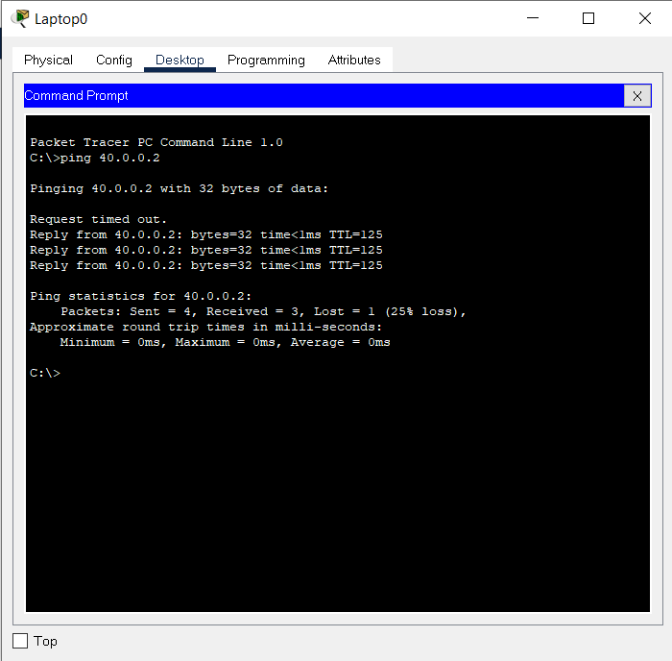

Laptop 1 to Laptop 0

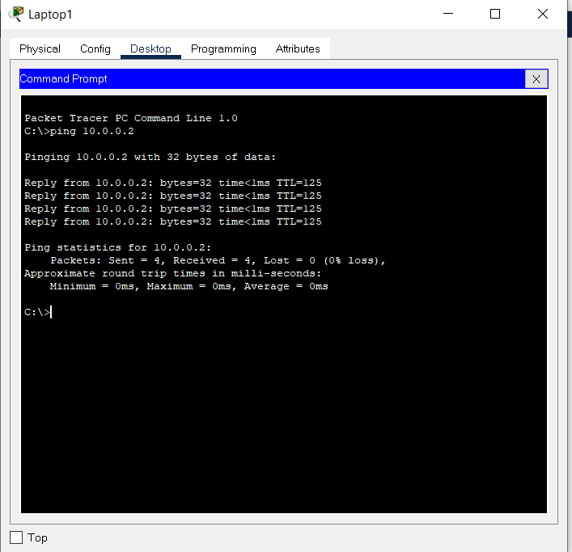

Eigrp

Laptop 0 to Laptop 1



Laptop 1 to Laptop 0



**Result and Conclusion:**

In this lab we created a simple Lan consisting of 2 laptops and 3 routers using both RIP and Eigrp protocols. Hence we learned about the RIP and Eigrp protocols.